CS 583: INTRODUCTION TO COMPUTER VISION

FALL 2013

PROJECT 1: HOMOGRAPHY

In this project, I should implement a program to (1) rectify an image (**Image Rectification**) (2) and superimpose one whole image or a part of an image into another (**Image Composite**) using manually selected correspondences on planar surfaces in the images. Along the way, you will learn how to compute homographies and how to use them to warp images.

The requirements of the assignment are:

1. Take your own images
2. Manually select corresponding points
3. Compute homography matrix
4. Warp the images
   1. Image Rectification: Compute fronto-parallel images
   2. Image Composite: superimpose one image into another
5. Implement masking
6. Implement linear blending

**IMAGE RECTIFICATION**

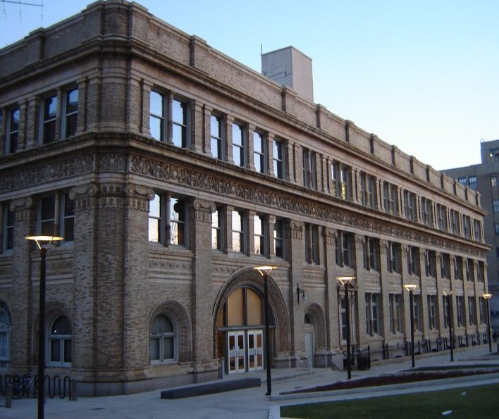 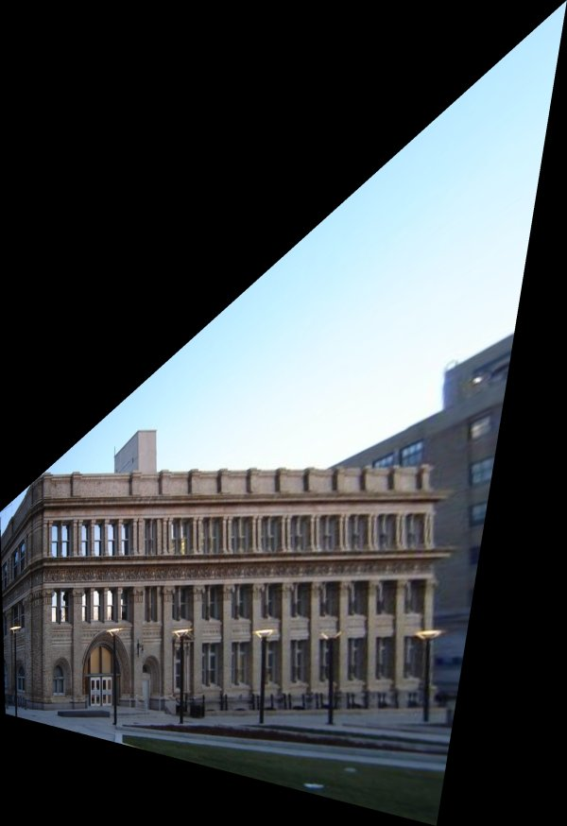 **Original Image** **Rectified Image**

**IMAGE COMPOSITE**

Face Laptop

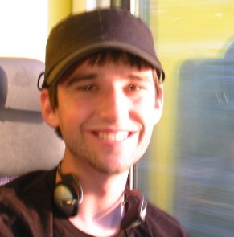 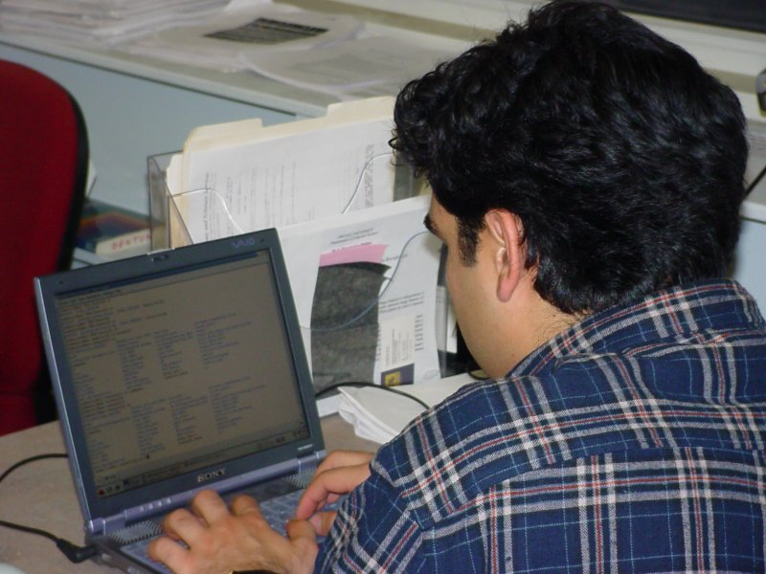

**Image Composite Output**

